PROJECT BACKGROUND
Sound Transit is building new light rail stations serving 14 stations with service to West Seattle in 2030 and Ballard in 2035. The new light rail lines and transit tunnel -- which will run under Downtown, South Lake Union and Seattle Center/Uptown -- are the largest transit investments in our city’s history. We are committed to engaging with communities early and consistently throughout this project in partnership with Sound Transit so that communities have frequent opportunities for input, and equity is centered in decision-making processes.

Q2 SUMMARY: COVID-19 Pause / Virtual Engagement
The City and Sound Transit paused most engagement with the public to allow for communities to respond to the COVID-19 pandemic. The City launched a digital survey in May, have continued to add resources to the website, and have been working on strategies to engage this summer and beyond. Our current efforts fall short of what we would assume for a project of this scale and we have expressed concerns to our partners, Sound Transit.
Since then, mass efforts around police reform and structural racism have taken priority for many community groups. While we are committed to continuing to engage the community in these processes when they have the capacity to do so, we want to ensure we are giving communities the space they need to address these pressing issues.
The Mayor sent a letter to the Sound Transit board to support delaying major decisions until there is the opportunity for more robust engagement. At present, current engagement opportunities are not sufficient to support the type of community-informed decision-making this project requires.

“In the continued challenges of COVID-19, I am concerned that ST cannot, at this time, know the depth or the length of the economic recession and the effects of social distancing on operations and ridership, and cannot collect focused, meaningful and equitable community input on environmental planning and design.”
– Mayor Jenny Durkan, letter to Sound Transit Board Executive Committee, June 10, 2020

QUARTER 2 HIGHLIGHTS
GUIDING PRINCIPLES SURVEY
The Racial Equity + Engagement (RE+E) Workgroup kept open the online versions of the Guiding Principles survey in English and top tier languages. The survey was opened in mid-May and will remain open until August 14. The draft Guiding Principles reflect years of community conversations about what matters to folks in Seattle and centers on key issues related to Dependable Transit, Vibrant Communities, Climate Action, and Equity.
1500
Survey
Responses
Intended outcomes:
- Obtain feedback on the draft guiding principles and whether they need to be refined
- Create visibility about this project and build community knowledge
TOP TIER LANGUAGES*
- Chinese (Simplified)
- Chinese (Traditional)
- Korean
- Somali
- Spanish
- Tagalog
- Vietnamese
*This list is informed by data from 2010 US Census and the 20xx American Community Survey

- Continue to engage the community – even as opportunities to do so are limited by COVID-19.
All websites (English and in-language) have been updated with short videos introducing the Guiding Principles survey

COMMUNITY FEEDBACK: GUIDING PRINCIPLES SURVEY
City staff created a set of guiding principles based on previous community conversations, including Sound Transit’s winter workshops and other engagement efforts. The guiding principles are high level and meant to help City elected officials and staff focus their efforts in areas that reflect community values. The survey offers an opportunity to rate guiding principles according to importance. Survey results to date are summarized here. After survey results are collected, City staff will adjust the guiding principles to reflect community members’ priorities more accurately. High-level results are reported here, and a more in-depth analysis will be forthcoming.

Dates: May 15 - present
How: City departments included links and information in e-newsletters, blog posts in addition to reaching out to community blogs and ethnic media outlets. The Seattle Department of Transportation (SDOT) hosted a week of Facebook and Twitter messages, and the Office of Planning and Community Development (OPCD) and the Department of Neighborhoods (DON) also used Facebook to share the survey. More than 1,500 surveys were collected.

LIMITATIONS OF VIRTUAL ENGAGEMENT
This quarter, due to the COVID-19 health pandemic, our primary engagements were email and the digital survey. We know digital techniques often do not reach people who are typically underrepresented in public processes, especially people of color and low-income city residents. At a summary level the results therefore reflect the views of community members who already have a high level of access and comfort with digital tools and the time to engage on this topic. More survey respondents are white as compared to the City population overall (81 percent of respondents vs. 64 percent of city residents), and the perspectives of communities of color are underrepresented. In addition, more than 60 percent of respondents has household incomes above $100,000. A full demographic breakdown of survey respondents can be found here.

To ensure the perspectives of people of color and people living on low incomes are represented, we will provide demographic response breakdowns in our comprehensive report-out after the survey is closed on August 14.

RESONANCE OF GUIDING PRINCIPLES
To gauge the resonance of the Guiding Principles, survey respondents were asked to identify how important each principle was to them. As of the publication of this report, the following percentages of respondents chose the below principles as either “Very Important” or “Extremely Important.”

Dependable Transit | 95 %  Extremely or Very Important | Climate Action | 79 %  Extremely or Very Important
Support efficient and reliable light rail service to your neighborhood that gets you where you need to go. | 95 %  Extremely or Very Important | Reduce our dependence on cars and give communities real, clean energy alternatives for transportation that reduces our impact on the changing climate. | 79 %  Extremely or Very Important
Equity | 66 %  Extremely or Very Important | Vibrant Communities | 64 %  Extremely or Very Important
Ensure race and social justice is the foundation for City decision making on light rail expansion. | 66 %  Extremely or Very Important | Create opportunities for housing and businesses located near stations that support your diverse community with more places for you to live, work and shop. | 64 %  Extremely or Very Important

TOP STRATEGIES FOR EACH GUIDING PRINCIPLE
For each Guiding Principle, survey respondents were asked to prioritize several strategies for ways to achieve the principle. The top surveyed strategy for each Guiding Principle is identified below. Full results can be found here.

GUIDING PRINCIPLE | MOST HIGHLY RANKED STRATEGY RELATED TO GUIDING PRINCIPLE | PERCENTAGE OF RESPONDENTS -- VERY OR EXTREMELY IMPORTANT
Dependable Transit | Connects you to work, school, shopping, and recreation in other neighborhoods | 92.7%
Vibrant Communities | Supports more affordable homes and retail spaces | 65.1%
Climate Action | Incentivizes walking, biking, and busriding through locating stations and city investments | 80.2%
Equity | Provides access to transit regrdless of language proficiency, physical ability, age, income, or other status | 81.3%

Q2 REFLECTION & LOOK AHEAD

WORKPLAN DELIVERABLE STATUS
DELIVERABLE | STATUS
Roadshow Engagement Materials & Staffing Plan | Completed
Community & Leadership Stakeholder Plan | Completed
Racial Equity Team (RET) Charter | Completed
Racial Equity Team (RET) Outreach Plan | Completed
Communications Plan & Collateral | Completed
Media | Completed

CHALLENGES IN Q2
CHALLENGE | OPPORTUNITY TO COURSE CORRECT
COVID-19 social distancing restrictions made targeted, in-person engagement with communities of color and lower-income communities impossible. Additionally, community attention remains on addressing reforms to police and racial justice. | It is important that communities are given the time and space to stay safe and healthy and adequately address these pressing racial justice issues. This collective work on centering community so they can identify equitable solutions has the potential to inform ST3 engagement as well.  We continue to evaluate modified engagement that will support an in-person feel with an online reality. We will be piloting some new strategies in early Q3.
Virtual engagement materials have skewed toward people with consistent access to technology who already have time and space to engage on public processes. | If virtual engagement may be the norm for the foreseeable future, more targeted online engagement grounded in relationships will need to be better integrated into outreach.  This will require close collaboration with the Community Liaison program as they build their online engagement strategies.

MATERIALS

NARRATED POWER POINT
A narrated presentation is now available on the website with English subtitles.

FACEBOOK ADS FOR THE GUIDING PRINCIPLES SURVEY
To encourage communities who prefer non-English materials, we ran Facebook ads in several languages. The total expenditure was $250, and they did not produce any additional non-English survey responses. We will take this as a learning experience for future plans around how to advertise to non-English speakers and try alternative strategies.
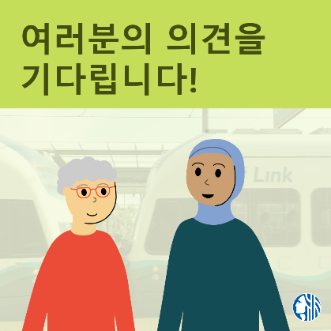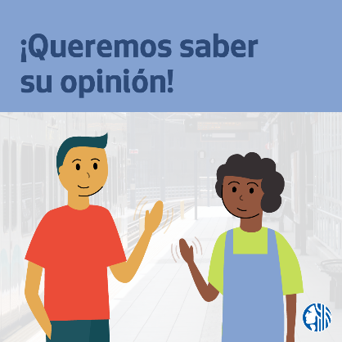

EXISTING RESOURCES

We continue to use the 2-pager and the Guiding Principles Survey. We have plans to close the survey on August 14.
WSBLE 2-pager Links |  |  | Guiding Principles Survey Links
English | Spanish | Vietnamese | English | Spanish | Vietnamese
Traditional Chinese | Korean | Somali | Traditional Chinese | Korean | Somali
Simplified Chinese | Tagalog |  | Simplified Chinese | Tagalog

WEBSITE

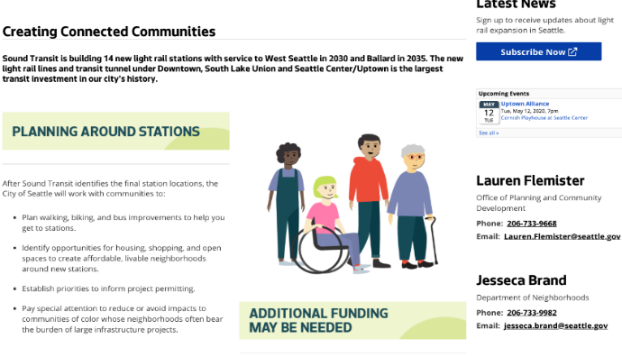
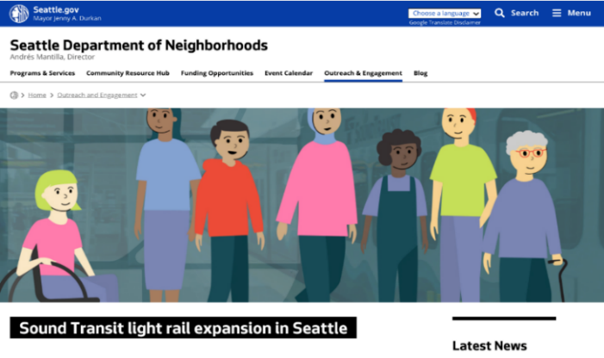
Seattle.gov/lightrail provides basic WSBLE project details in English as well as pages in all Top Tier languages. Visitors can sign up for the e-newsletter, contact staff and see upcoming events.
ACCESSIBILITY REPORT CARD
Our goal is to ensure that the materials we create and events we host are welcoming and accessible to all people. For example, the documents on our website should work well for screen readers and people using other assistive technologies.
The Revised Section 508 standard, which provides guidance for creating accessible documents and other tools, includes a checklist of criteria. We chose criteria from the standard that are most relevant to the types of materials we are currently creating and are using them to evaluate the materials we share. The Accessibility Scorecard for Q2 2020 on our website. This quarter we got a 100 percent accessibility score, though we only produced one new item!

RACIAL EQUITY + ENGAGEMENT WORKGROUP
The Racial Equity + Engagement (RE+E) Workgroup is led by Jesseca Brand in the Department of Neighborhoods and is comprised of multiple city departments who are coordinating with Sound Transit to conduct community engagement with the public. The goal of this workgroup is to ensure that racial equity, social justice, and community engagement are integral to City and Sound Transit decision-making throughout the project and that community voices are reflected in final outcomes and decisions.

